Technical Appendix: Methodology for Energy Security & Economic Opportunity Indices

1. Purpose and Architecture of the Composite Indices
The appendix describes a multipillar decision framework that scores energy related technologies and trade partners along three lenses:
Pillar | Question answered | Unit of analysis
Energy Security (ES) | “How exposed is the United States (or a partner) to supply shocks, import dependence and resource scarcity for a given technology and stage of the supply chain?” | Country × Technology × Supply-chain stage*
Economic Opportunity (EO) | “Where can U.S. firms most profitably and feasibly expand production, exports or investment?” | Same as above
Partnership Strength (PSI) | “Which bilateral relationships deliver the best mix of reduced risk, commercial upside and executability?” | Country (aggregate across techs)
* Supply chain stage can up-, mid- and downstream. Upstream refers to the extraction of raw materials for respective technology; midstream refers to converting the raw materials to the finished product for respective technology (e.g. batteries); downstream is the industry associated with distribution/after-sales support/lifecycle management.
Each pillar is an index-of-indices: the code first turns dozens of raw metrics into comparable 0–1 scores, then blends them with explicit weights to obtain composite indices. The workflow is fully reproducible, authors used an R-based code.

2. Converting Raw Data into Comparable Scores
- Percentile transformation with an S-curve.
- median_s-curve(x, γ = 0.5)
  - Step 1 – percentile-rank every observation.
  - Step 2 – reshape the cumulative distribution with: $f\left(r\right)= \frac{r^{γ}}{r^{γ}+{(1-r)}^{γ}}$
where γ < 1 flattens the middle and steepens the tails.
  - Practical effect: extreme performers get extra credit/penalty; mid-pack countries are compressed.
- Two data types. Every metric is kept twice:
  - raw – the physical unit (e.g., EJ of net gas imports);
  - index – the S-curved percentile.
Analysis downstream always uses the index columns so that heterogeneous variables (percent, kt, $) can be averaged.
- Aggregation rules.
  - Within category (e.g., “Reserves”): simple un-weighted mean of the relevant sub-indices.
  - Across categories into a pillar: weighted mean using domain-specific importance weights (see section 4).
  - Technologies are scored separately for Up-, Mid- and Down-stream segments to keep mining, manufacturing and power-generation issues distinct.

3. Data Model
Dimension | Values used
Technologies | Batteries, Green Hydrogen, Solar, Wind, EVs, Nuclear, Oil, Gas, Coal, Geothermal
Supply-chain stages | Upstream (mining & fuels) • Midstream (processing & manufacturing) • Downstream (power or end-use)
Countries | 170+ with special attention to the allies vector (USA, CAN, JPN, …)

4. Pillar Construction Details
Pillar component | Variables
Energy Security | Foreign dependency (net-import share, cleantech market-share concentration); Reserves (fossil & critical minerals); Resource availability; Energy access & growth; Critical-mineral trade indices
Economic Opportunity | Trade competitiveness (RCA, export size, feasibility distance); Production capacity & growth; Demand growth & size (IEA WEO & BNEF NEO); Cost competitiveness (LCOE, equipment cost); Investment momentum (BNEF & Clean Investment Monitor); Over-capacity signals
Partnership Strength | Combines friend-shoring risk (inverse of ES for U.S. imports), export opportunity, development / enabling environment plus U.S. outbound FDI and formal energy MoUs.  Final blend: 0.4 × Friendshore + 0.4 × Opportunity + 0.2 × (1 – Dev Environment).
Market concentration is measured with the Herfindahl–Hirschman Index (HHI); its complement (1 – HHI) is S-curved so that low concentration (i.e., diversified supply) scores high.
Detailed specification of component (sub-)indices

4.1 Energy Security pillar
Gauges the security and resilience of a technology’s supply chain for the U.S. It incorporates the factors like domestic resource reserves, import dependence, and supply concentration. For example, it averages metrics on critical mineral availability (e.g. U.S. share of global lithium, cobalt, graphite, rare earth reserves), fossil fuel import reliance, and market concentration (HHI) of key inputs. These inputs can be compared across countries or sectors.
Overall, a high Energy Security index means the U.S. has secure or diversified supply (low risk), whereas a low score signals heavy reliance on foreign sources or a chokepoint. For example, The U.S. scores high on solar downstream and gas upstream security due to high domestic consumption and reserves, as well as low import reliance. However, it scores low on solar or nuclear midstream supply security, since solar components and materials are largely imported and concentrated in China and US nuclear manufacturers have low market share and high import reliance.

Methodology
Weight in pillar† | Sub-index (category) | What is measured | Normalization & aggregation | Key data source(s)
5 | Foreign-  dependency composite | Exposure to non-allied suppliers across the value chain. Built from:  - Clean-tech manufacturing market-share index (solar, wind, battery, electrolyser, heat-pump).  - Critical-mineral supply security index (market-share & HHI across 4 priority minerals).  - Electric vehicle midstream manufacturing index. | Each raw share/HHI is converted to a 0-1 score with median_scurve(γ = 0.5); technology-level indices are simple means; the category score is an un-weighted mean across technologies, then percent-ranked across countries. | IEA Energy Technology Perspectives 2024; IEA Critical Minerals database 2025; IEA Global EV Outlook 2024.
4 | Energy-  import dependence | Net import share for oil, gas, coal. | Import share (%) → scurve; country score is mean of three fuels. | EI Statistical Review of World Energy 2024 (formerly BP)
5 | Reserves | In-ground reserves of (i) four critical minerals and (ii) oil, gas, coal. Critical-mineral subscores are weighted by 2024 demand share of each mineral in clean-tech deployment. | Reserves in physical units → scurve; mineral subscores demand-weighted; fossil fuels treated analogue. | EI Statistical Review of World Energy 2024 (tabular PDF & wide XLSX)
3 | Critical-  mineral trade balance | Export market share, export HHI & -import concentration for Li, Co, Ni, graphite & REEs. | Export & import shares → scurve; security sub-index = mean(market-share, HHI); demand-weighted across minerals. | UN Comtrade 2023 bulk extract; IEA Critical Minerals database
2 | Trade concentration (energy goods) | Overall trade depth, RCA, feasibility & global market-share for 50 + energy-sector HS codes at 4- and 6-digit level. | Exports, RCA, “distance” → scurve; overall trade index = mean of four scores; technology-level HHI is added. | Harvard Atlas of Economic Complexity v2
3 | Energy access & consumption | Per-capita consumption of six primary fuels in 2023 and 2018-23 growth. | Raw fuel / capita and growth (%) → s-curve; scores averaged. | EI Statistical Review

Results
Exhibit XX illustrates the constituent indices used to calculate the Energy Security Composite Index for battery technology, disaggregated by the upstream, midstream, and downstream stages of the value chain. Each constituent metric is derived from raw data and transformed into a relative ranking, as detailed in the methodology table above.
To contextualize the results, the exhibit presents scores for the highest-GDP country in each continent. This allows users to better understand how the United States’ constituent indices are constructed relative to global peers across different segments of the battery supply chain.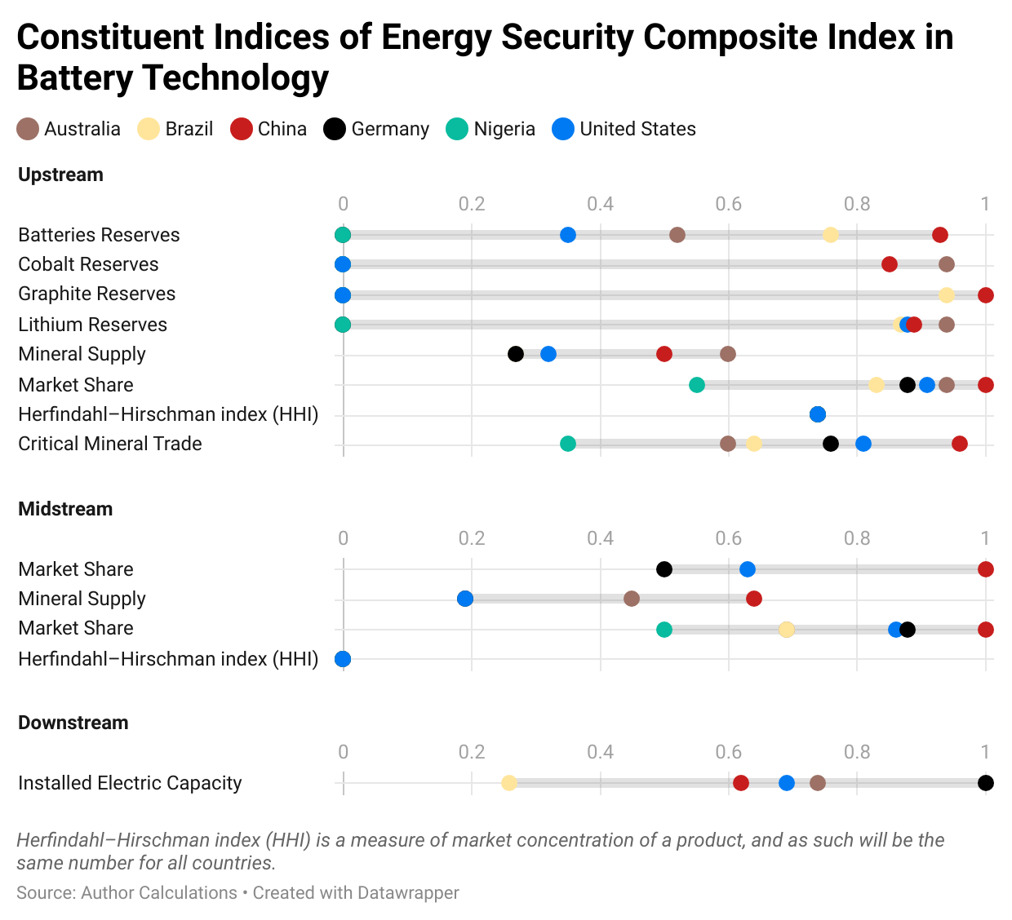

4.2 Economic Opportunity pillar
Measures the economic and industrial upside for the U.S. in each energy technology and supply chain. It blends indicators of market size, growth, and domestic industrial base. For instance, it considers U.S. demand (e.g. energy consumption per capita and projected growth for the tech), production capacity (manufacturing share of the global market), cost-competitiveness (e.g. relative energy prices, such as electricity costs, that affect manufacturing), and innovation potential (R&D or pipeline projects).
Overall, a high score indicates a technology where the U.S. stands to gain significant jobs, exports, or industrial leadership in the coming decade. For example, electric vehicles (EVs) show high economic opportunity – large domestic market demand and major growth globally – whereas conventional solar panel manufacturing currently shows lower U.S. opportunity (the industry is dominated by overseas suppliers, and the U.S. has limited market share). However, emerging areas like advanced nuclear and geothermal register rising opportunity, given growing global interest and areas of U.S. technical strength.

Methodology
Weight in pillar‡ | Sub-index | What is measured | Normalisation & aggregation | Key data source(s)
5 | Future demand | Global demand size (2035) & growth (2023–35) for each fuel/technology. Size & growth combined at 1 : 2 ratio. | Each raw value → scurve → (size + 2 × growth)/3 → scurve. | IEA World Energy Outlook 2024 (STEPS) and BNEF New Energy Outlook 2024 (ETS).
4 | Production depth & momentum | 2023 production, 2018-23 growth & absolute growth for upstream (fossil, mineral) and downstream (generation) activities. | Three raw metrics → scurve → mean → scurve. | EI Statistical Review 2024; IEA Mineral Supply 2025.
4 | Export feasibility | Revealed-comparative-advantage, “distance” in product space & export scale for energy-product HS codes. | Each metric → scurve → mean → scurve. | Harvard Atlas (OEC).
3 | Market share (manufacturing) | Country share of 2035 global manufacturing capacity in five clean-tech supply chains. | Share → scurve. | IEA ETP 2024 capacity outlook.
3 | Mineral supply security | Same index as in Energy-Security but here treated as the business risk related to global market concentration | See above. | IEA Critical Minerals.
3 | Energy-consumption growth | 2018-23 per-capita energy-use growth index (see §4.1). | scurve. | EI Statistical Review.
3 | Domestic investment momentum | Five-year growth and level of US clean-energy CAPEX by tech × chain (currently US only). | Size & growth → scurve → mean. | Clean Investment Monitor (Rhodium/BNEF, Q4-2024).
3 | Over-capacity premium | Global over-capacity ratio in the manufacturing supply chain (inverse scored). | Index = 2^(-over-capacity ratio); then scurve. | BNEF Energy Transition Supply-Chains 2025.
3 | Global LCOE competitiveness | Mid-scenario LCOE in 2024 & 2050 for solar, wind, gas, coal, batteries. | LCOE $/MWh → scurve. | BNEF LCOE Data Viewer 2025.
3 | Global demand (SAM) | BCG serviceable addressable market 2020-50 for US exporters (US only). | SAM, scurve. | BCG custom analysis.

Results
To contextualize the Economic Opportunity index calculation, the country wise of a select group (top GDP country in each continent) of constituent indices for battery technology in exhibit xx below:

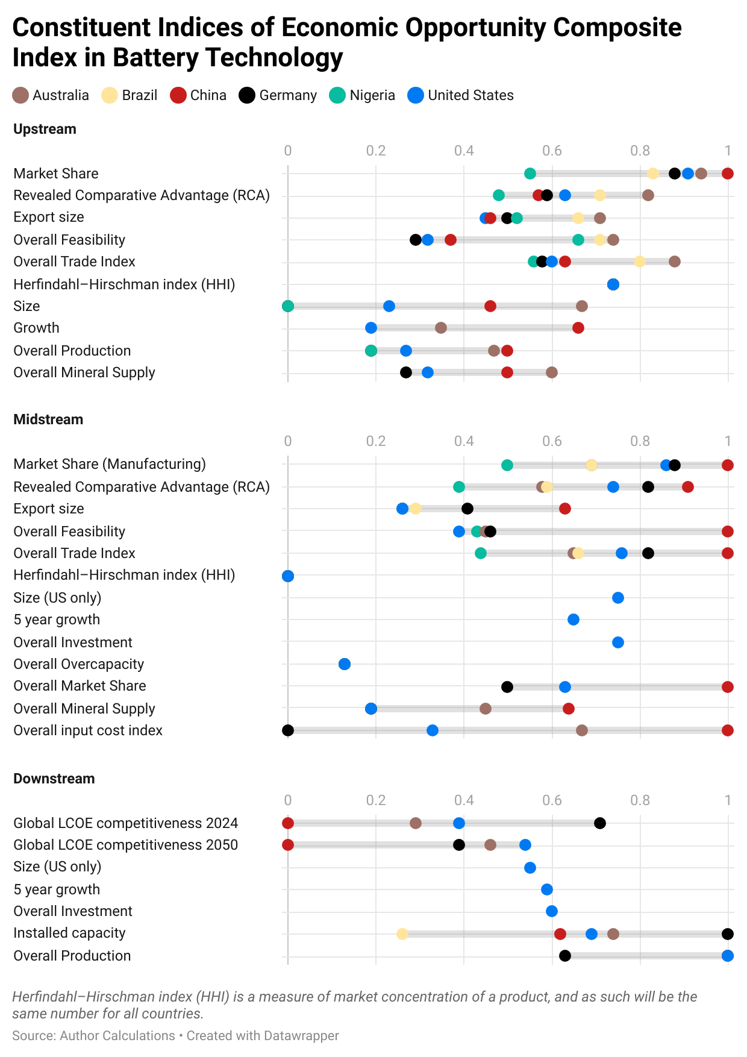

4.3 Partnership-Strength indices
Assesses the strategic value of international partnerships in each sector, indicating how well-positioned the U.S. is to Friendshore (partner with allies), Develop (create stronger partners), or Trade (shape global markets). This index combines metrics such as U.S. trade with allied countries (import/export volumes and growth for the given technology), co-investment flows, and the presence of bilateral energy agreements or partnerships. The index has three sub-components, together merged into a final strength index:
- Friendshoring index (“Safer)
  - Index capturing the friendshoring opportunity, based on imports by sector, local energy security index, partner economic opportunity index, high-level local-partner investment relationship, and adjusting by sectoral climate impacts depending on partner climate policy ambition.
- Export-opportunity index (“More Prosperous)
  - Index capturing the energy export potential, based on exports by sector, the local economic opportunity index, partner energy security index, and adjusted by sectoral climate impacts depending on partner climate policy ambition.
- Development Need Index (“Stronger”)
  - Index capturing the development need while accounting for local economic opportunities, based on World Bank Development Indicators, World Bank Doing Business Rankings, partner energy security index, local Export-opportunity index, local economic opportunity index, local energy security index. Not adjusted for climate considerations.
- Country-level Partnership-Strength Index (PSI)
  - Overall partnership strength index capturing all three indices above at 0.40 × Friend-shore score + 0.40 × Export-opportunity score + 0.20 × Development score.

Weight in pillar† | Sub-index (category) | What is measured | Normalization & aggregation | Key data source(s)
1 (Safer pillar) | U.S. import trade exposure | 12-month moving-average value of U.S. imports of each HS-6 clean-energy product from partner i; growth since 2020. | - import_12mma and import_index_20 each → 0-1 with median_scurve(γ = 0.5).  - us_import_index & us_import_growth_index averaged ⇒ us_trade_index.  - us_trade_index re-scurved to keep cross-country comparability. | U.S. Census International Trade API (timeseries/intltrade/imports/hs, 2020-01→2025-02); HS-code list from energy_codes.
1 (Safer) | Energy-security gap | Degree to which the United States is insecure in each tech-segment (1 – U.S. energy-security score). | Partner inherits U.S. “Overall Energy Security Index” for the same tech × supply_chain; values → 0-1 via median_scurve. | Internal Energy Security composite (built earlier in report).
1 (Safer) | Economic-opportunity (partner) | Partner’s own “Overall Economic Opportunity Index” in the same tech-segment. | 0-1 via median_scurve. | Internal Economic Opportunity composite.
1 (Safer) | U.S. outbound investment footprint | Size & share of U.S. FDI in partner along supply-chain segment (Up/Mid/Down). | For each segment:  - size_index = scurve(dollar stock)  - share_index = scurve(% of global)  - Segment score = mean(size_index, share_index) ; then scurved again. | BEA “U.S. Outward Direct Investment” XLSX (sheet 7).
-0.2 (Safer adj.) | Climate-penalty | Punishes dirty tech when partner has strong climate policy. | penalty = (1 − ghg_index) × climate_policy_index; deducted from base composite (us_friendshore_index_unadj − 0.2 × penalty). | • IPCC AR5 WG III median LCA intensities → ghg_index (min-max reversed).  • Climate Action Tracker ratings → climate_policy_index (0.25 – 1).
— | US Friend-shore Index (“Safer”) | Risk-adjusted value of sourcing a tech from partner i. | Base composite = mean(four 0-1 sub-indices above); penalty applied; final score scurved. | Aggregates rows above.
2 (Prosperous) | U.S. export trade exposure | 12-month value & growth of U.S. exports of each HS-6 product to partner i. | Same construction as import index but on export flow; weights 2:1 inside Pros-index. | Census export API (exports/hs).
1 (Prosperous) | Economic-opportunity (U.S.) | Same tech-segment “Overall Economic Opportunity Index” but benchmarked to U.S. | 0-1 S-Curve. | Internal composite.
0.25 (Prosperous) | Energy-security gap (partner) | Partner’s own energy-security vulnerability in the segment (higher = U.S. leverage). | S-Curved to 0-1 and entered with 0.25 weight. | Internal Energy Security composite.
-0.33 (Prosperous adj.) | Climate-penalty | Same functional form as Safer; larger coefficient (-0.33) to reflect reputation risk in export markets. | (1 − ghg_index) × climate_policy_index, scaled by 0.33 and subtracted. | Same IPCC & CAT sources.
— | US Opportunity Index (“Prosperous”) | Export-led upside in partner i. | Weighted mean (2 : 1 : 0.25) of three sub-indices – penalty; final scurve. | Aggregates rows above.
≈ 1⁄6 each (Stronger) | Development-potential composite | Six factors: (i) inverse GDP/Doing-Business, (ii) partner & U.S. energy-security gaps, (iii) partner economic opportunity, (iv) U.S. export-opportunity. | Each raw metric → scurve; simple mean of six; scurved again so high = high need/potential. | • World Bank WDI & Doing Business 2019.• Internal Energy & Opportunity indices.• Census export API.
0.4 / 0.4 / 0.2 (PSI) | Partnership Strength Index (PSI) | Country-level composite of Safer, Prosperous & Stronger pillars. | psi = 0.4·Safer + 0.4·Prosperous + 0.2·Stronger; lanes assigned by tercile thresholds (≥ 0.66, ≥ 0.33). | Outputs of rows above.

4.4 Source summary
Dataset | Vintage used | Main variables pulled
EI Statistical Review of World Energy | 2024 edition | Production, consumption, prices, reserves for ~70 fuels & minerals
IEA Energy Technology Perspectives | 2024 | 2035 manufacturing capacity by tech
IEA Critical Minerals Market Review | 2025 (accessed Mar-2025) | Supply, demand, reserves for Li, Co, Ni, graphite, REE
IEA World Energy Outlook | 2024, STEPS | Global demand trajectories
BNEF | LCOE 2025, Supply-Chains 2025, NEO 2024, Investment-Trends 2025 | LCOE, over-capacity, demand, CAPEX
Clean Investment Monitor | Q4 2024 | Quarterly US CAPEX by tech & segment
Harvard Atlas of Economic Complexity | 2023 release | Exports, RCA, product-space “distance”
UN Comtrade | 2023 | HS-6 trade flows for critical minerals
US Census ITDS | 2020-25 monthly | HS-10 exports & imports
World Bank WDI & Doing-Business | 2024 refresh | 15 governance & finance indicators
(See embedded comments in the code for line numbers and transformations.)

5. Key Methodological Choices & Their Implications
Choice | Rationale | Policy-relevant implication
S-curve rescaling instead of z-scores | Avoids giving undue leverage to outliers while still rewarding leadership. | Middle-of-the-pack countries cluster tightly; only clear leaders/laggards stand out, which is intuitive for diplomatic prioritization.
Separating supply-chain stages | Risks and opportunities differ between mining and manufacturing. | Enables granular policy (e.g., midstream battery incentives vs. upstream lithium diplomacy).
Fixed weights (expert judgement) | Transparent and easy to tweak in future iterations. | Scores are sensitive to weights; policymakers should rerun scenarios if priorities shift (e.g., security > economics).
Percentile-based indices | Sidesteps unit conversions. | Absolute magnitude is lost; a 1 Mt surplus and a 0.1 Mt surplus can both look “high” if they top the sample. Interpret rankings, not exact distances.
Technology-neutral basket | Captures both legacy (coal, oil) and transition (hydrogen, EVs) sectors. | Highlights trade-offs: boosting LNG exports may help EO but harm ES via methane.

6. Data Sources and How They Are Used
Source | Use in code
EI Statistical Review of World Energy 2024 | Fuel production/consumption, fossil & mineral reserves, energy prices.
IEA Critical Minerals 2025 dataset | Mineral demand shares (weighting), production & HHI, supply-security index.
IEA Energy Technology Perspectives 2024 | 2035 manufacturing capacity & market shares for solar, wind, batteries, heat-pumps, electrolyzers.
IEA World Energy Outlook 2024 | Global demand projections (Stated Policies).
BloombergNEF (LCOE 2025, New Energy Outlook 2024, Supply-Chain Over-capacity 2025, Investment Trends 2025) | Cost competitiveness, demand scenarios, capacity utilization, national clean-energy investment.
Harvard Atlas of Economic Complexity | Trade RCA, export size, feasibility distance.
UN Comtrade 2023 | Country-level export/import shares for 50+ critical mineral HS codes.
Clean Investment Monitor (Rhodium/RMI) | U.S. quarterly real-asset investment by technology.
World Bank WDI & Doing Business | Macro development, governance & investment-climate indices.
U.S. Census International Trade API | Monthly U.S. export & import growth by HS-4/6 code (friend-shoring).
BCG Serviceable Addressable Market study | Long-run ($) market size for U.S. firms.
Misc. bilateral/MoU tracker (internal spreadsheet) | Binary score of formal energy agreements.
Each dataset is ingested, cleaned and matched to a common (Country, Technology, Supply-chain) key; missing values are defaulted to zero before indexing to avoid listwise deletion.

7. Reading the Results
- Scores are relative. A country can score high even if its absolute reserves are modest—as long as peers are lower.
- Positive directionality: higher index = more secure, more opportunity, stronger partner (after inversions where appropriate).
- Composite “lanes.” The final PSI map classifies partners into Friend-shore, On-shore substitute, Targeted Development Assistance or Monitor/Niche. These are decision categories for financing and diplomatic engagement rather than performance grades.

8. Recommendations for Policymakers
- Stress-test the weights. If geopolitical risk trumps economics, increase the ES weight and rerun— the code is parameterised for easy re-calibration.
- Use stage-specific levers. A partner may be strong downstream (assembly) but weak upstream (raw materials); tailor financing instruments accordingly.
- Look beyond the headline score. Drill into the sub-indices to understand why a country scores low— e.g., poor import balance vs. limited reserves—before prescribing policy.
- Update quarterly. Several inputs (U.S. trade, investment) refresh frequently; the percentile logic ensures new data slots in without re-baselining.

This appendix aims to make the statistical scaffolding transparent so that end-users—from analysts to senior officials—can replicate, audit and adapt the framework as new data or priorities emerge.

Quill Robinson and Ryan Featherston, “Assessing the United States’ Solar Power Play,” Center for Strategic and International Studies, July 1 2024, https://www.csis.org/analysis/assessing-united-states-solar-power-play.
World Nuclear Association, US Nuclear Fuel Cycle, World Nuclear Association, November 20 2024, https://world-nuclear.org/information-library/country-profiles/countries-t-z/usa-nuclear-fuel-cycle.
International Energy Agency, Solar PV Global Supply Chains, International Energy Agency, July 2022, https://www.iea.org/reports/solar-pv-global-supply-chains/executive-summary.
Allan, How the U.S. Can Stop Losing the Race for Clean Energy, 2025.

